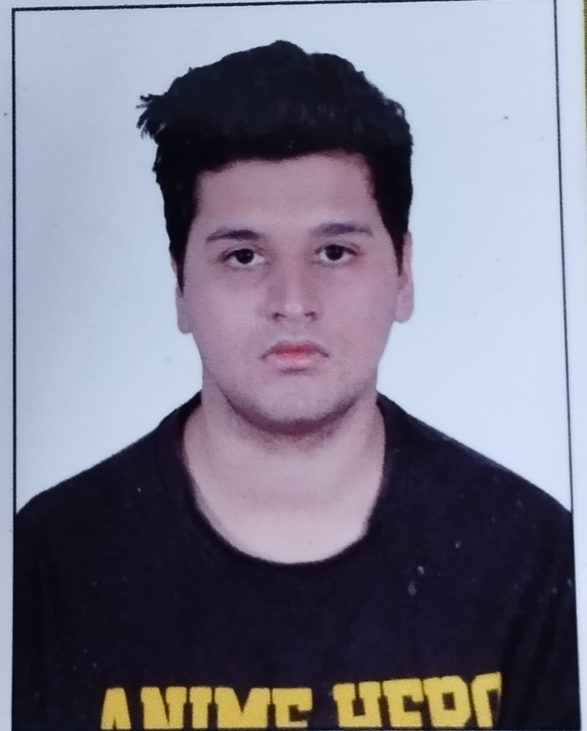 |  | KUSHAGRA PAPNAI  STUDENT
Profile  Kushagra Papnai enrolled in VIT Vellore for 4 year B.Tech Programme on Electrical and Electronics Engineering. Proficient in Semi-conductors and motors. Passionate in implanting and participation in new projects that have capability to change the future. Looking for a bright future ahead.  Contact  PHONE:  8077011051  Current Address:  VIT Vellore, Katpadi  EMAIL:  kushagrapapnai@gmail.com  Hobbies  Football  Exercise  Learning Languages |  | EDUCATION  ST.THERESA.SR.SEC.SCHOOL  03-04-2010 – 23-03-2018  Student of the Year in 3rd, 5th standard  DELHI PUBLIC SCHOOL  23-04-2018 – 14-05-2022  96% in 10th CBSE Board Examination  Student of the Year in 8th standard  Represented school in Inter -school competitions  HEERA LAL PUBLIC SCHOOL  05-05-2022 – 29-05-2024  90% in 12th CBSE Board Examination  VIT, VELLORE  22-07-2024-  SKILLS

